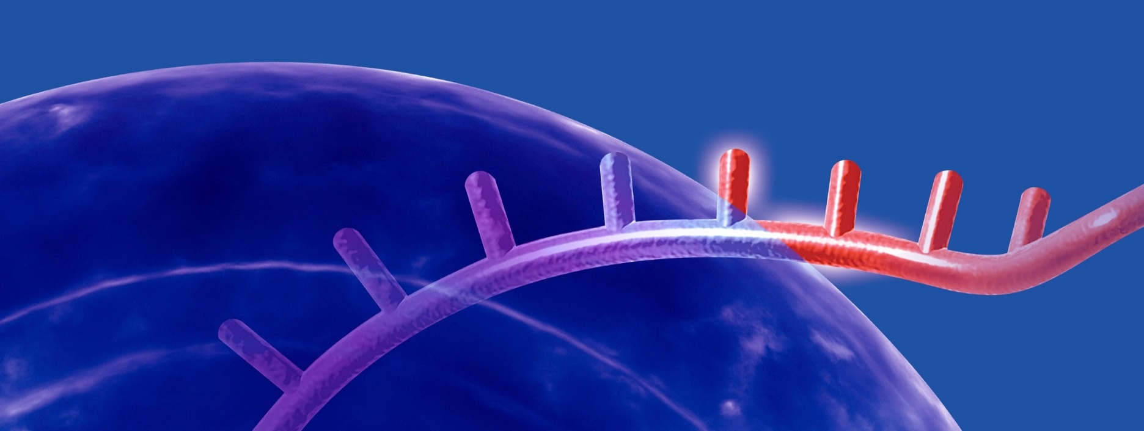

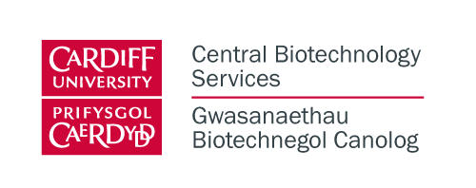
Gene Expression Workshop
Thursday 24th October
Come and join our workshop on
QPCR and Microarray Technologies

Venue: Cardiff University, Cathays Park Campus
Glamorgan building, Committee room 2
King Edward VII Avenue, Cardiff CF10 3WT
Time: 10 am – 3 pm
Hosts: Dr Claudia Consoli (CBS Facility Lead QPCR), Dr Amanda Redfern (CBS
Facility Lead Microarray and NGS), Jane Chappelle (CBS Business Development Manager)
Speakers: Jennifer Lines (Genetic Analysis Consultant, ThermoFisher Scientific), Dr James Curtis (QPCR Specialist, ThermoFisher Scientific), Dr Geoff Scopes (Field Applications Scientist, Microarray, ThermoFisher Scientific)

Agenda:
10.00 Registration/coffee
10.15 Introduction to ThermoFisher Scientific and Central Biotechnology Services
11.00 QPCR workshop - Introduction to technology, range of applications and analysis
12.30 Lunch - Refreshments provided to everyone registered (see below)
1.30 Microarray workshop - Introduction to technology, range of applications and analysis
3.00 Close

Registration is required
To register please email: Jane Chappelle chappellej@cardiff.ac.uk

For any further questions please email:
Claudia Consoli consolic@cardiff.ac.uk, Amanda Redfern redfernaj1@cardiff.ac.uk

