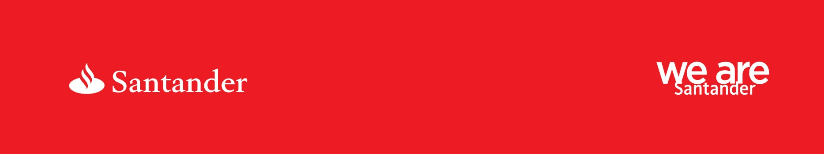

Job Title: | Sub-Sector Specialist, Manufacturing (Chemical, Pharmaceuticals & Life sciences) – National
Region: | National
Salary: | Competitive
Date Closes:
Ref Number: | A21415

Turn big plans for your career into action

We are currently have an exciting opportunity for a Sub-Sector Specialist to join our Manufacturing sector, with a specific focus and expertise across Chemical, Pharmaceuticals and Life sciences.
The Sector Strategy team was established to align to our International differentiator’s with domestic clients and companies that we support. Developing a sector based proposition of products, knowledge and support, focused on the needs of their industry challenges.
The Sub-Sector Specialist is expected to have deep knowledge of their specific sector, including all trends, regulations, industry and government bodies and relevant legislation governing the sector; as well as understanding of competitor propositions, which we can benchmark against.

Sub-Sector Specialists need to be visible at key events related to their sector in order to drive brand awareness, host round tables, virtual trade missions and other events focused on their sectors. They will also be expected to visit key clients and prospects within their sector; forming relationships with key industry partners and professionals, that may act as strategic partners and sources of leads and opportunities.

The location of this role is flexible, with frequent nationwide travel required.

We’re passionate about helping people and businesses prosper and we strive to be simple, personal and fair in everything we do. That’s why we’ve built a culture of respect, where everyone is empowered to keep their promises and go above-and-beyond for our customers, colleagues and the communities we serve.

As a Sub-Sector Specialist your main responsibilities will be
- Working with relationship teams to come up with innovative solutions to complex client requests; acting as a strategic partner for clients and prospects, to help them grow their business
- Liaising with Risk, Product Proposition teams, Finance, Legal, T&O, and others, in order to develop client centric and competitive sector propositions based on client/market demand
- Undertaking market research and due diligence to gauge needs and requirement of clients in the sector and development of propositions based on the findings
- Producing thought leadership pieces for publication, in order to discuss sector specific trends and provide insight
- Managing both internal and external relationships – internally with Country Specialists, International BD Directors and Relationship teams, and externally with key industry bodies and professionals
- Speaking to prospects and liaising with Relationship teams, in order to maximise business opportunities and drive primacy

Minimum skills and experience required
- Understanding of Commercial & Corporate banking
- Deep sector- specific knowledge and up to date knowledge of trends within that sector
- Ability to assess the impacts of sector changes on the existing portfolio
- Experience working in a financial target and business origination environment
- Good written and oral language skills, in order to articulate effective solutions related to the area
- Ability to speak or present, in public, and discuss our propositions to an internal and external audience
- Experience of negotiating with and influencing prospects
- Up to date knowledge of regulatory/sector specific changes in the industry
- Ability to undertake financial analysis and opine on credit papers from a sector perspective, in order to influence credit decisions

Rewarding you
Salary is competitive
For your commitment and success, Santander offers a competitive basic salary with a distinct career development opportunity. In addition to your salary and bonus, we offer you a benefits package that’s flexible and allows you to be in control, as well as all the policies, tools and guidance to support you.
Other Santander benefits include:
- Pension with generous contributions from Santander
- 30 days’ holiday plus bank holidays, with the option to purchase up to 5 contractual days per year
- £6,000 car allowance per year
- Company funded Individual Private medical Insurance
- Voluntary healthcare benefits at discounted rates such as Private medical insurance for your family, Dental insurance, Healthcare Cash Plan and Health assessments
- 24/7 access to an online employee discount platform. Save money on everything from groceries, electronics, fashion, holidays and much more
- Benefits supporting you and your family, such as Childcare vouchers, voluntary Life assurance and Critical illness
- Access to an All Employee car scheme
- Excellent employee recognition schemes, be recognised for demonstrating great behaviours
- Share in Santander’s success by investing in our Sharesave and Partnership shares plans
- Support your favourite causes through charitable giving and our community partnerships
Location

The location of this role is flexible, with frequent nationwide travel required.

Why Santander?

We’ll give you more than a job, we’ll give you a purpose – to help people and businesses prosper.

Our aim is to be the best bank for our people, customers, shareholders and communities and we’re making it happen by focusing on the behaviours that bring everyone together. By bringing passion, talking straight, embracing change, showing respect, speaking up, keeping promises, giving support, truly listening and actively collaborating, we believe we can really make a difference.

We’ve created an environment where we always put people first, that’s why we offer flexible work options to help you do your job in a way that suits you. Whatever your unique ambitions, you’ll have plenty of room to grow, with tailored training and development opportunities and a wide range of benefits designed to suit your lifestyle. What’s more, we’ll also support you in making a difference through our volunteering and fundraising schemes. Our commitment to our people hasn’t gone unnoticed and we’ve been listed as one of Britain’s Top Employers by the Top Employers Institute since 2012.

Time to apply

If this sounds like a role you’re interested in then please apply on the link below.

